The Clemson Human Factors and Ergonomics Society (HFES Website)
IE 802-Project #4: Detail Design, Testing, Refinement, and Delivery
Sumonthip Chompoondang Gmitro
12/10/2012

INTRODUCTION
The Clemson HFES website is used to keep Clemson HFES members involved by informing them of upcoming events, keep alumni informed of events and opportunities for them to stay involved with the organization, allow non-members to research the organization and encourage them to join, and allow companies to research the organization and provide Clemson HFES with opportunities for professional development. In general, our stakeholders emphasized the following primary needs: the website is informative, interactive, easy to navigate, and visually appealing (see Appendix A for a full list of needs and personas). In Project 2 we created target specifications, resulting in a metric and a value for each need. Metrics of the Clemson chapter Human Factors and Ergonomics Society (HFES) website were compared to Virginia Tech’s HFES website (Appendix B). In general, benchmarking data showed the current Clemson HFES website is up to date, is effective in getting information to members on how to join and upcoming events, and provides users with the function of online payments. However, the current website fails to provide enough useful information that users can access quickly and efficiently, and the visual aesthetics of the website currently fail to satisfy users’ needs and expectations. By comparing performance between the Clemson HFES and Virginia Tech HFES websites, the team defined marginally acceptable and ideal values of performance for each metric as target specifications for our future concept. In Project 3 we generated, evaluated, and refined concepts that would be capable of satisfying the target specifications developed in Project 2, resulting in a single design concept carried on to detail design in Project 4.
The goal of Project 4 is to iteratively design, test, and refine our concept to create a final working website that will be launched in place of the existing Clemson HFES website. We will discuss methods used and results found from this process for 4 iterations, and the concept selection process, followed by conclusions of the project as well as future recommendations.
ITERATION 1
Method
For the first iteration of our detail design, the team first had to choose a platform that would be best to launch our new website from. After Project 3, the team had identified Wix and Word Press as the most promising platforms because they were both free and provided easy maintenance for future webmasters. To choose the final platform, members needed to become more familiar with each one first (see Appendix C). Three team members made a Clemson HFES website in Wix (although only completed the Home and Events pages) to see exactly how easy or difficult it would be and to see which features of our final concept from Project 3 could be implemented using Wix. One team member did the same using Word Press. At the end of the week, each team member asked current HFES members for subjective feedback on their designs and then met to choose the final platform.
Results
Although Wix had many attractive template options, offered both HTML and Flash versions, and was found to be easy to use for the team to build the website and for any webmaster to maintain the website, the team ultimately chose to pursue Word Press because it was a more established platform with fewer ‘bugs,’ and was viewed as more professional to hand down to future webmasters and for future website visitors. Additionally, although Wix offered both HTML and Flash, the team decided that Flash options would not be favorable because the website could not be viewed on Apple products. Our initial website concept using Wordpress can be seen in Appendix X.
Discussion
Although either platform would have probably been acceptable, the team was confident in their final choice to build the new Clemson HFES website using Word Press. Although it requires more time to build from scratch than Wix, webmaster duties were still viewed to be as easy to complete as on a Wix platform because no code is required to edit events, student publications, member directory, and the calendar.
ITERATION 2
Method
In Iteration 2, the remaining pages were created in Word Press based on our final concept selected in Project 3 (see Appendix D). Subjective and objective feedback (N = 5) was gathered from HFES members on pre-existing pages, Home and Events, as well as for new pages, Join HFES, Research, Annual Meeting, Usability Projects, Jobs & Internships, and Contact Us.
Results
Subjective feedback was generally positive but still provided many insights on improvements that needed to be made. For example, users thought the website was “professional” and “clean and modern” but had other general recommendations regarding font and layout. For example, many users wanted larger, higher contrast fonts, did not see the social media links because they blended in with the background, were confused about how to post a comment, or didn’t like that the new site still did not connect with other departmental sites. Other specific areas for improvement were identified for each page and can be found in Appendix D. However, the objective feedback collected was very positive. For example, satisfaction with ability to navigate the website improved to an average of 5 on a 1-5 scale, which was much higher than the 1.25 rating given to the original website.
Discussion
Testing of the first complete iteration of the website identified several specific areas for improvement, as would be expected. However, objective feedback was very encouraging because marginally acceptable or ideal values had already been met for the metrics that were measured. The team continued Iteration 3 by making the improvements identified by user testing.
ITERATION 3
Method
In this iteration more content was added to the website and the navigation of the website was developed further (Appendix E). Prior to this point, there were no nested pages on the website, but in this round of development, headers were considered more carefully and secondary pages were created where appropriate. Images were also added to the website where appropriate to enhance the visual appeal of pages. Also, during this iteration, the team began the process of understanding webhosting and how Wordpress worked with various webhosts. Iteration 3 was tested with once again with representative users (N = 4). It was important to test the navigation of the new secondary pages added to the website in this iteration. Users were given the chance to explore the layout of the website and were asked to think aloud and rate their satisfaction with the navigation of the website.
Results
Users rated the navigation of the website a 4.3 on a 1-5 scale. Though this number was fairly high there were still some issues encountered by our users. One user felt that links should not only be blue and underlined but should say “click here for more information on this topic.” Another user felt that the header “membership” was not clear enough, though this was the only user who reported this problem. With these exceptions, the other users reported finding what they expected to find under all section headers. Finally, the contrast of the social media links with the website and the legibility of the font were once again listed a problems from our users. We tried to increase the font in this iteration but the layout of the headers and home page was too stretched with this different font.
Discussion
We were able to successfully increase the complexity of the website structure and the content of the pages in this iteration. Most of our tested users were able to easily navigate the website and reported high satisfaction with their ability to move around the website. The problems that our users did encounter in this round were one of our focuses in the final iteration.
ITERATION 4
Method
With the feedback from iteration 3 as a guide, the website was once again refined and tested in our final iteration (see www.clemsonhfes.org, Appendix G). In this round of design, content was considered a main priority. The team met with the webmaster, president, and usability chair for the Clemson HFES chapter to discuss the information needed on the website and the organization of that information. From the meeting with the webmaster and president, the team discovered that Clemson HFES would like to be a resource for human factors information for students and those seeking HF information outside of the organization. Pages the highlight out contributions to the field of HF (like the publications page) and resources for HF researchers (i.e. the top 20 HF resources page) were added to the website to increase the usefulness of this website to HF students and professionals. From our meeting with the usability chair, we discovered that Clemson HFES would like to reach out to future usability employers and to student volunteers. Information for both these groups of people was added to the website.
Additionally, the background of the pages was changed to orange to increase the contrast of the buttons with the background. This color change also provided more visual appeal and clearly identified Clemson HFES as affiliated with Clemson University. The font color was changed from gray to black to increase font contrast. Unfortunately, font size was not increased due to a limitation with the Wordpress theme chosen. The team is searching for possible font fixes to implement after this project has concluded. With these changes, the website was tested for performance on the metrics specified in Project 2.
Results
Seven users provided subjective and objective feedback in this final round of website testing. Our final website site design was not complete when this testing took place. The following pages were still under construction during this round of testing: view calendar of all events, view our top 20 HF resources, see our usability work, view jobs and internships, and meet our members. These pages were tested with a smaller group of users (N = 2) once they were completed.
The final website was tested using the metrics developed earlier in this project (Appendix F. The team did not meet only 1 of the set target specifications pertaining to the need that the website be a “useful tool” (need 16, metric 19). This need was measured through a subjective survey question that asked users to rate (1-5 scale) the extent to which they believed the website was a useful tool to them. Though the target specification for this metric was ≥4.5 this item was only rated a 3.5 by our users. However, the website was rated by these very same users as a 4.5 on the metric that asked them the usefulness (need 3, metric 3) of the website. We believe the key difference in these two metrics is the word “tool.” For some reason, though users thought the website was useful they did not view it as a very useful tool for their use.
Our target specifications were met for the rest of our 44 metrics and 38 needs. In fact, we met 12 of our ideal specifications and significantly improved website performance over the original Clemson HFES website. Metrics in which the ideal specifications have been met are highlighted in yellow in the table presented in Appendix F. We will report here areas in which we saw significant improvement over the original website. Clemson HFES is an event based organization and therefore it is very important for members of this organization to be able to quickly find upcoming events. Finding upcoming events took almost a minute with the original website, and though this is not very slow, it only takes 10 seconds for our users to find this information using the new website (need 2, metric 2). It is also important that the website be informative (need 12, metric 14). Users rated the informativeness of the original website a 2 on a 1-5 scale, but the new website was rated a 4.5 on this same scale. Users were also very satisfied with their ability to connect to Clemson HFES social media outlets (need 13, metric 16) giving this metric a 4.7 satisfaction rating with the new website in comparison to a 1 with the original website. The new website is also a time saver for the organization webmaster (need 18, metrics 21, 22). It now takes only 3 steps (5 steps with original website) and a little over 2 minutes (4 minutes with original website) to post an event. The new website was also highly rated on the ability to navigate the website and find the information that the user was searching for (needs 35, 36, metrics 41, 42). Users rated their ability their ease of finding information a 2.3 with the original website and a 4 with the new website and their ability to navigate the website a 1.3 with the original website and a 4.3 with the current website. Finally, all aesthetic changes to the website had a major impact on how the website is perceived by users. Users reported finding the new website to be more professional, trustworthy, modern, visually appealing, and eye catching than the original website (needs 22-30, metrics 27-35).
We also added in new functionality to the website based on the needs specified by our stakeholders that was well received. The website is now linked to Clemson HFES social media outlets (need 13, metric 15) which users were very satisfied with (satisfaction rating of 4.7). Joining Clemson HFES can now be completely entirely online and 100% of users tested were able to easily complete this action (need 15, metric 18). A list of student publications, presentations, and awards was also added to the new website and users were satisfied with their new ability to find this information (satisfaction rating of 4; need 9, metric 10). Finally, members can also now post and view job and internship opportunities quickly (posting takes only a minute) and satisfactorily (rating of 5; need 19, metric, 23).
Finally, our team successfully met our cost specifications. It will cost Clemson HFES $20 a year to continue to maintain their domain name but there webhosting and web building services were free and have not incurred any initial implementation costs (needs 37, 38, metrics, 43, 44).
Discussion
Our team was able to successfully improve the Clemson HFES website well past the performance of the original website. By adding new functionality, improved navigation, new content, and an updated appearance we were able to make the Clemson HFES website more useful and informative for our stakeholders. It should be noted that there were two pages of the website that we not completed by the conclusion of this project: view our usability work and our top 20 HF resources. For legal considerations, Clemson HFES is currently contacting all past usability employers to determine how much of their work can be released online. For our top resources, Clemson HFES will be slowly building this list of resources over the next year and this process has not begun yet.
CONCLUSIONS
The team was able to successfully design a website that met the needs of all of our stakeholders. This website has improved content and functionality and is up to date and professional in appearance. The website has already gone “live” and is the first search result on Google when searching for Clemson HFES. We believe we have created an aesthetically pleasing website that will be useful to current, past, and future members.
RECOMMENDATIONS
Our website has been successfully delivered to our client and to the members of HFES. The official unveiling of the new website will take place in the new year. Additionally, this website will continue to be improved upon as a usability project for the members of the HFES usability team in the future.

REFERENCES
Ulrich, K. T., and Eppinger, S. D. (2012). Product Design and Development. New York, NY: McGraw-Hill.

Appendix A: PERSONAS AND SCENARIOS
Josh is the Clemson HFES webmaster. He is a 4th year PhD student and tries to keep the website very up-to-date on current activities and events. The president of HFES asks Josh to write up the organizations past events to qualify as a Gold Chapter for National HFES. Josh looks on the website to see all of the past events that have been done by Clemson HFES. While on the website, Josh remembers that he needs to update the website but doesn’t have a lot of time today. Thankfully, it is easy and quick to update the website even though he doesn’t have much formal training with website creation. Josh needs to update the HFES social media pages and accesses these pages through the website, which makes updating multiple sites a lot faster. Josh also wants to see how many people come to the website to view his post and he is able to track website visits to the website. Josh is really proud of his work on the website and feels like it represents Clemson HFES very well with its professional and unique appearance.
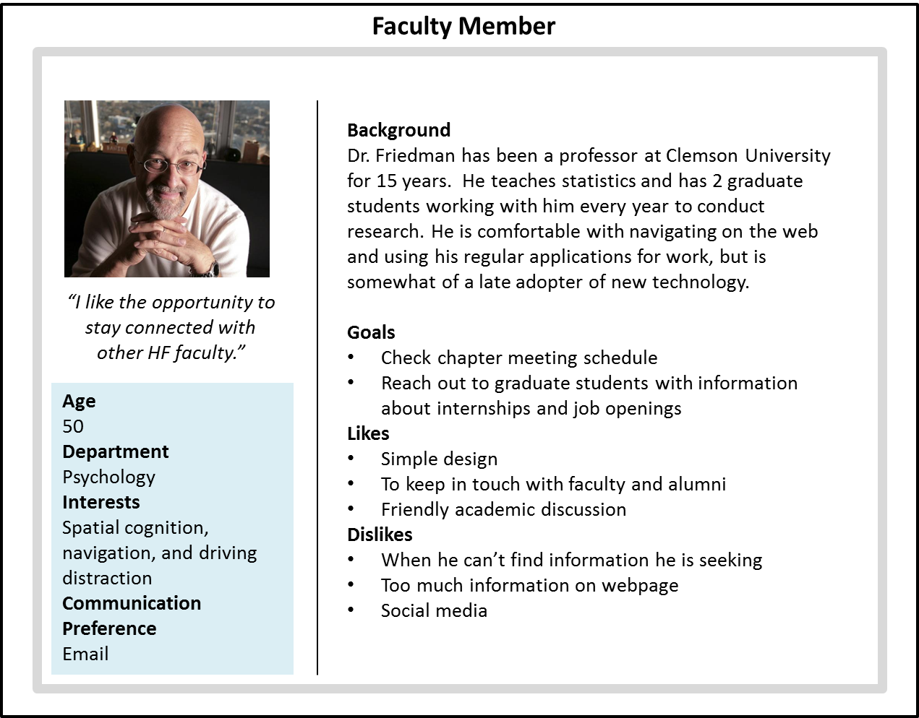
Dr. Friedman is a professor in the Human Factors Psychology program at Clemson. He just remembered that he needs to pay his dues for the year and decides to try using the Clemson HFES website. Once on the website, he realizes that he hasn’t attended a Clemson HFES event in the last year, and is curious about who current members are and what sort of research they do. While searching the Clemson HFES website, Dr. Friedman sees a post from a co-worker on a hot topic in HF and decides to post his opinions on the subject as well.

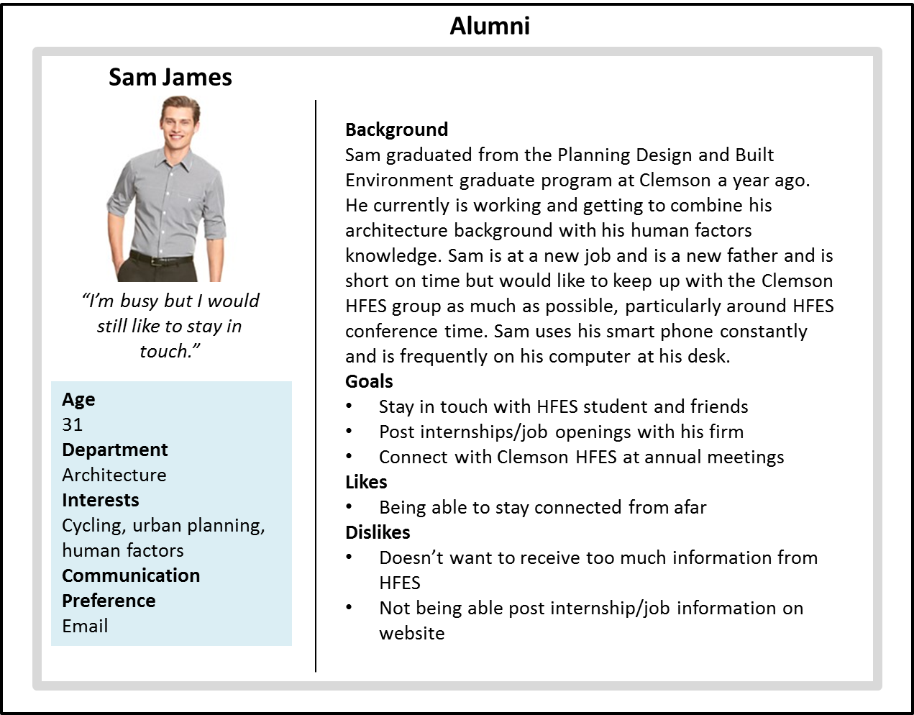
Sam graduated from the Planning Design and Built Environment graduate program at Clemson a year ago. Sam just found out that his company, Battelle is hiring a new human factors graduate in the next few months and Sam decides to post this opening on the HFES website. Sam finds it to be quick and easy to post this information. While on the website Sam realizes that the annual conference is coming up and finds out if Clemson HFES will be sponsoring any event this year that he would want to attend. Sam sees on the website that Clemson HFES is raising money for Clemson Community Care through a 5K run and donates money to the runners through the website.
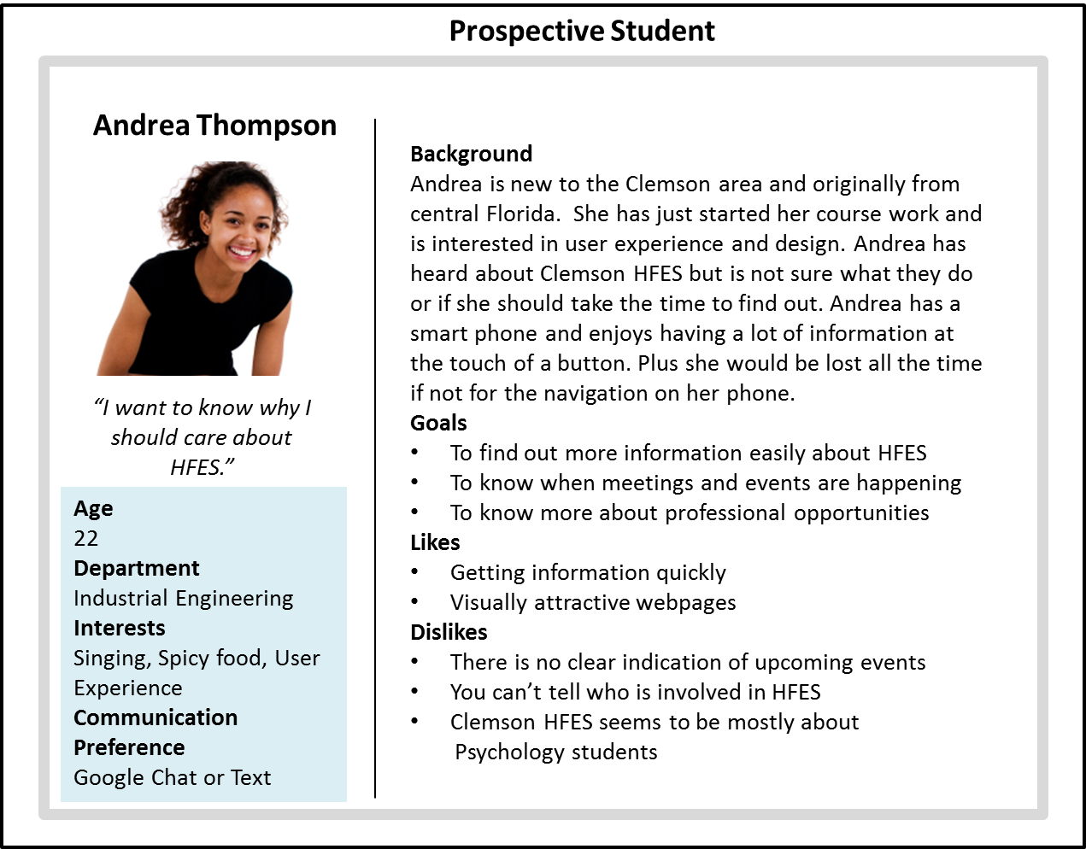

Andrea is new to South Carolina and has just started her first year at Clemson. Andrea had heard a lot about HFES and was able to find out more about who HFES was and what they did through the HFES website. She recently attended the first meeting and decided that she wanted to join HFES which she was able to do online after the meeting. She is looking to hang out with other HF people and uses the website to connect with other HFES members via social media outlets. Andrea is able to navigate the website efficiently and likes that the website is able to bring her attention to the upcoming events. Additionally, she has been able to use the website to find out more information about the national HFES organization.

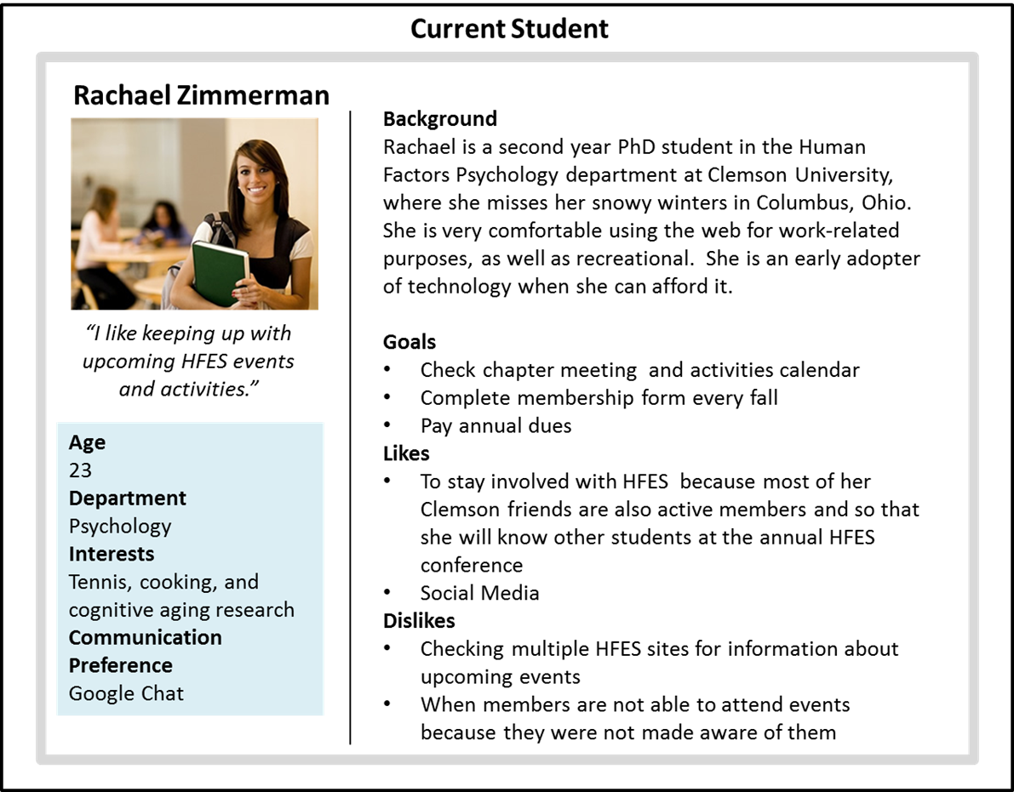

Rachael is a second year PhD student in the human factors psychology program. She recently completed her membership form using the website and likes being able to pay her dues online. She is looking forward to the upcoming bowling event and is looking on the website for more information. She is also looking forward to the HFES national meeting in Boston. She unfortunately missed the deadline for submitting a paper this year, but she is using the Clemson HFES website to read up on paper submission guidelines for the conference next year. Rachel prefers using the Clemson HFES website to the national HFES website because it’s easy to navigate and is more attractive. While on the website, Rachael remembers that she took a picture at the last Clemson happy hour event and uses the website to link to the HFES social media page to post this picture.

Appendix B: competitive Benchmarking chart

Metric No. | Need No. | Metric | Avg. Importance Rating | Units | Existing Website | Virginia Tech HFES Website | Target Specifications
 |  |  |  |  |  |  | Marginal | Ideal
1 | 1 | # of participants able to find information about joining HFES (Andrea's scenario) | 4.95 | % | 100 | 100 | 100 | 100
2 | 2 | Time for "Rachael" to find a specific upcoming event (Rachael's scenario) | 4.3 | Seconds | 56.25 | 3 | ≤ 15 | ≤ 5
3 | 3 | User rating of usefulness | 4.8 | 1-5 subj. scale | 2.17 | 2.6 | ≥ 4 | ≥ 4.5
4 | 4 | # of correct responses to knowledge test of current HFES members and officers for Clemson HFES (Andrea's scenario) | 3.2 | % | 50 | 50 | ≥ 75 | ≥ 90
5 | 5 | # of posted upcoming events vs. # of actual upcoming events (Josh's scenario) | 4.45 | % | 100 | 0 | 100 | 100
6 | 6 | # of correct responses to knowledge test of upcoming events for Clemson HFES (Andrea's scenario) | 4.85 | % | 100 | 0 | 100 | 100
7 | 7 | # of sources members use to get information | 2.65 | # | 2 | N/A | ≤ 2 | ≤ 1
8 | 8 | User rating of satisfaction with the publishing information presented on the Clemson HFES website | 3.35 | 1-5 subj. scale | 2.25 | 2.4 | ≥ 3.5 | ≥ 4.5
9 | 9 | # of participants able to find information on student publications on the Clemson HFES website (Dr. Friedman's scenario) | 3.7 | % | 0 | 0 | ≥ 40 | ≥ 60
10 | 9 | Dr. Friedman's satisfaction with his ability to find publications by Clemson HFES members (Dr. Friedman's scenario) | 3.7 | 1-5 subj. scale | 1 | 3 | ≥ 3 | ≥ 4
11 | 10 | # of participants who correctly respond with the Clemson HFES sponsored event at the national conference (Sam's scenario) | 3.5 | 1-5 subj. scale | 50 | 0 | ≥ 75 | ≥ 90
12 | 11 | # of participants able to find past events and name 1 past event conducted by Clemson HFES (Josh's scenario) | 4.2 | % | 100 | 100 | 100 | 100
13 | 11 | # of correct responses to knowledge test of past events for Clemson HFEs (Andrea's scenario) | 4.2 | % | 0 | 100 | ≥ 40 | ≥ 60
14 | 12 | User rating of how informative the Clemson HFES website is | 4.4 | 1-5 subj. scale | 2 | 3.2 | ≥ 4 | 5
15 | 13 | # of participants able to reach a social media page (Andrea's scenario) | 4.35 | % | 0 | 0 | ≥ 50 | ≥ 75
16 | 13 | "Rachael's satisfaction with her ability to connect to social media via the Clemson HFEs website (Rachael's scenario) | 4.35 | 1-5 subj. scale | 1 | 1.5 | ≥ 3 | ≥ 4
17 | 14 | # of social media links on the Clemson HFES website (Josh and Andrea's scenario) | 3.45 | # | 0 | 0 | ≥ 2 | ≥ 3
18 | 15 | # of participants able to pay online (Rachael, Dr. Friedman, and Sam's scenarios) | 3.55 | % | 75 | 0 | ≥ 75 | ≥ 90
19 | 16 | Andrea's rating of how useful of a tool the Clemson HFES website (Andrea's scenario) | 3.8 | 1-5 subj. scale | 3 | 3 | ≥ 4.5 | 5
20 | 17 | # of participants able to join Clemson HFES online (Andrea's scenarios) | 4.8 | % | 0 | 0 | ≥ 50 | ≥ 70
21 | 18 | # of steps Josh takes to update one event on the Clemson HFES website (Josh's scenario) | 3.65 | # | 5 | N/A | ≤ 4 | ≤ 3
22 | 18 | Time for Josh to complete this task (Josh's scenario) | 3.65 | Seconds | 240 | N/A | ≤ 180 | ≤ 120
23 | 19 | Time it takes for participants to post a job opening on the Clemson HFES website (impossible task - time to give up) (Sam's scenario) | 4.15 | Seconds | impossible | Impos-sible | ≤ 60 | ≤ 45
24 | 19 | Sam's satisfaction with his ability to post a job opening on the Clemson HFES website (Sam's scenario) | 4.15 | 1-5 subj. scale | 1 | 1 | ≥ 3 | ≥ 4
25 | 20 | Josh's ease of use score for current platform (Josh's scenario) | 4.1 | 1-5 subj. scale | 2 | N/A | ≥ 3 | ≥ 4
26 | 21 | Josh's satisfaction with his ability to track the number of website visits (Josh's scenario) | 3.3 | 1-5 subj. scale | 4 | N/A | ≥ 4 | 5
27 | 22 | Rating of the look and feel of the Clemson HFES website | 3.05 | 1-5 subj. scale | 1.6 | 2.8 | ≥ 4 | 5
28 | 23 | "Rachael's", "Andrea's", "Josh's" rating of the professionalism of the Clemson HFES website (Rachael, Andrea, Josh's scenario) | 4.05 | 1-5 subj. scale | 1.17 | 3.4 | ≥ 4 | 5
29 | 24 | "Rachael's", "Andrea's", "Josh's" rating of the trustworthiness of the Clemson HFES website (Rachael, Andrea, Josh's scenario) | 4.65 | 1-5 subj. scale | 2.83 | 3.2 | ≥ 4 | 5
30 | 25 | "Rachael's", "Andrea's", "Josh's" rating of how modern the Clemson HFES website is (Rachael, Andrea, Josh's scenario) | 4.55 | 1-5 subj. scale | 1.17 | 2.8 | ≥ 4 | 5
31 | 26 | "Rachael's", "Andrea's", "Josh's" satisfaction with the visual appeal of the Clemson HFES website (Rachael, Andrea, Josh's scenario) | 3.95 | 1-5 subj. scale | 1.17 | 2.4 | ≥ 4 | 5
32 | 27 | User rating of the informative nature of image descriptions | 4.05 | 1-5 subj. scale | 1.33 | 1.4 | ≥ 3 | ≥ 4
33 | 28 | User rating of the satisfaction of the use of images | 3.4 | 1-5 subj. scale | 1.5 | 2.2 | ≥ 3 | ≥ 4
34 | 29 | "Rachael's", "Andrea's", "Josh's" rating of the attention catching capacity of the Clemson HFES website (Rachael, Andrea, Josh's scenario) | 4.6 | 1-5 subj. scale | 1.80 | 2.33 | ≥ 4 | 5
35 | 30 | "Rachael's", "Andrea's", "Josh's" satisfaction with the layout of the Clemson HFES website (Rachael, Andrea, Josh's scenario) | 4.45 | 1-5 subj. scale | 1.67 | 2.6 | ≥ 4 | 5
36 | 31 | Dr. Friedman's satisfaction with his ability to communicate with other members and faculty using the Clemson HFES website (Dr. Friedman's scenario) | 4.35 | 1-5 subj. scale | 1 | 2.33 | ≥ 3 | ≥ 4
37 | 32 | # of links to other HFES organizations | 3.8 | # | 1 | 13 | ≥ 3 | ≥ 5
38 | 32 | User satisfaction with website links to other department websites | 3.8 | 1-5 subj. scale | 1.2 | 3.17 | ≥ 4 | 5
39 | 33 | # of participants able to find out about submitting to conference (Rachael's scenario) | 3.2 | % | 0 | 0 | ≥ 30 | ≥ 40
40 | 34 | # of participants able to find out date of national HFES meeting (Rachael's scenario) | 3.35 | % | 25 | 0 | ≥ 75 | ≥ 90
41 | 35 | Dr. Friedman's rating of ease of finding information using the Clemson HFES website (Dr. Friedman's scenario) | 4.95 | 1-5 subj. scale | 2.33 | 3 | ≥ 4 | 5
42 | 36 | "Rachael's" satisfaction with her ability to navigate the Clemson HFES website (Rachael's scenario) | 4.95 | 1-5 subj. scale | 1.25 | 3 | ≥ 4 | 5
43 | 37 | Estimated expense of maintenance cost per year | 2.5 | $/year | 20 | N/A | ≤ 40 | ≤ 20
44 | 38 | Estimated expense of initial implementation cost | 2 | $ | 0 | N/A | ≤ 75 | 0

*NA = Not Available

*Impossible: currently not a function users were able to perform

APPENDIX C: ITERATION 1

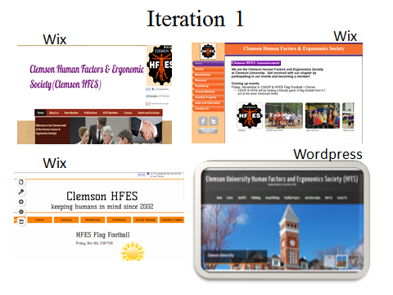
APPENDIX D: ITERATION 2
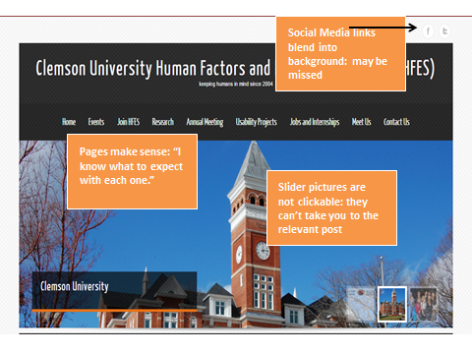
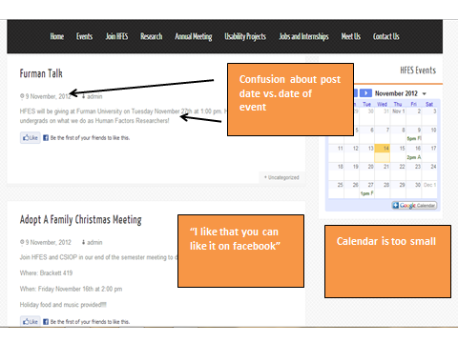
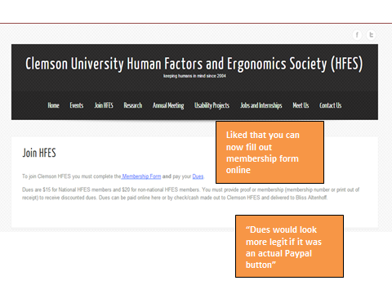
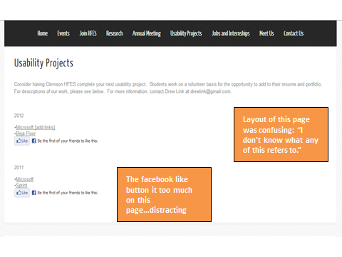
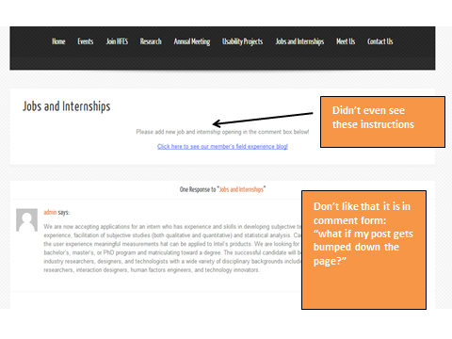
APPENDIX E: ITERATION 3
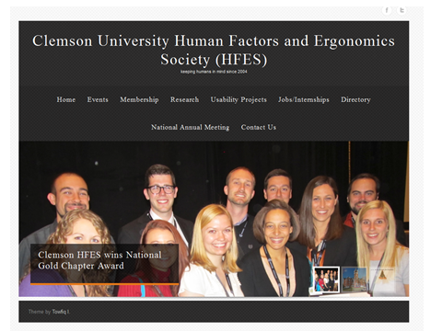
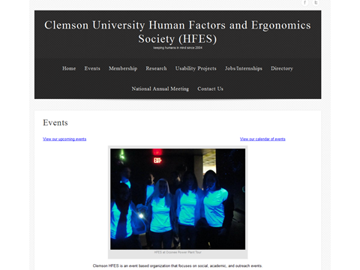

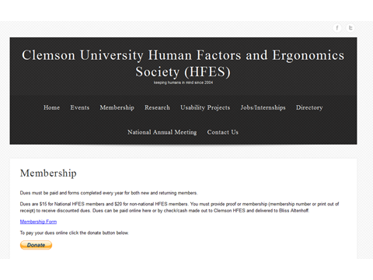
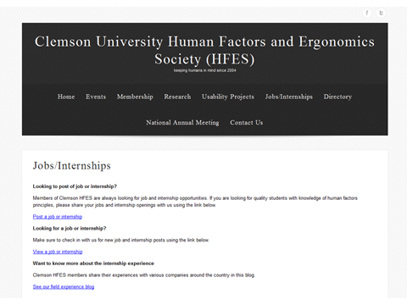
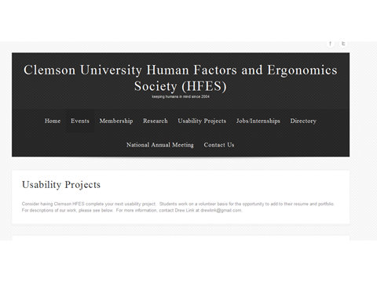
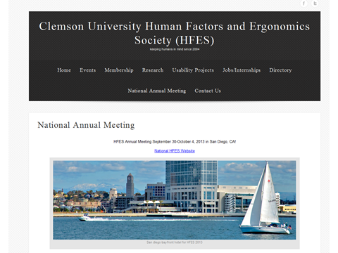

APPENDIX F: FINAL TARGET SPECIFICATIONS

Metric No. | Need No. | Metric | Avg. Importance Rating | Units | Target Specifications |  | Original Website | Final Website
 |  |  |  |  | Marginal | Ideal
1 | 1 | # of participants able to find information about joining HFES (Andrea's scenario) | 4.95 | % | 100 | 100 | 100 | 100
2 | 2 | Time for "Rachael" to find a specific upcoming event (Rachael's scenario) | 4.3 | Seconds | ≤ 15 | ≤ 5 | 56.25 | 10
3 | 3 | User rating of usefulness | 4.8 | 1-5 subj. scale | ≥ 4 | ≥ 4.5 | 2.17 | 4.5
4 | 4 | # of correct responses to knowledge test of current HFES members and officers for Clemson HFES (Andrea's scenario) | 3.2 | % | ≥ 75 | ≥ 90 | 50 | 80
5 | 5 | # of posted upcoming events vs. # of actual upcoming events (Josh's scenario) | 4.45 | % | 100 | 100 | 100 | 100
6 | 6 | # of correct responses to knowledge test of upcoming events for Clemson HFES (Andrea's scenario) | 4.85 | % | 100 | 100 | 100 | 100
7 | 7 | # of sources members use to get information | 2.65 | # | ≤ 2 | ≤ 1 | 2 | 3
8 | 8 | User rating of satisfaction with the publishing information presented on the Clemson HFES website | 3.35 | 1-5 subj. scale | ≥ 3.5 | ≥ 4.5 | 2.25 | 4
9 | 9 | # of participants able to find information on student publications on the Clemson HFES website (Dr. Friedman's scenario) | 3.7 | % | ≥ 40 | ≥ 60 | 0 | 100
10 | 9 | Dr. Friedman's satisfaction with his ability to find publications by Clemson HFES members (Dr. Friedman's scenario) | 3.7 | 1-5 subj. scale | ≥ 3 | ≥ 4 | 1 | 4
11 | 10 | # of participants who correctly respond with the Clemson HFES sponsored event at the national conference (Sam's scenario) | 3.5 | 1-5 subj. scale | ≥ 75 | ≥ 90 | 50 | 100
12 | 11 | # of participants able to find past events and name 1 past event conducted by Clemson HFES (Josh's scenario) | 4.2 | % | 100 | 100 | 100 | 100
13 | 11 | # of correct responses to knowledge test of past events for Clemson HFEs (Andrea's scenario) | 4.2 | % | ≥ 40 | ≥ 60 | 0 | 100
14 | 12 | User rating of how informative the Clemson HFES website is | 4.4 | 1-5 subj. scale | ≥ 4 | 5 | 2 | 4.5
15 | 13 | # of participants able to reach a social media page (Andrea's scenario) | 4.35 | % | ≥ 50 | ≥ 75 | 0 | 100
16 | 13 | "Rachael's satisfaction with her ability to connect to social media via the Clemson HFEs website (Rachael's scenario) | 4.35 | 1-5 subj. scale | ≥ 3 | ≥ 4 | 1 | 4.7
17 | 14 | # of social media links on the Clemson HFES website (Josh and Andrea's scenario) | 3.45 | # | ≥ 2 | ≥ 3 | 0 | 2
18 | 15 | # of participants able to pay online (Rachael, Dr. Friedman, and Sam's scenarios) | 3.55 | % | ≥ 75 | ≥ 90 | 75 | 100
19 | 16 | Andrea's rating of how useful of a tool the Clemson HFES website (Andrea's scenario) | 3.8 | 1-5 subj. scale | ≥ 4.5 | 5 | 3 | 3.5
20 | 17 | # of participants able to join Clemson HFES online (Andrea's scenarios) | 4.8 | % | ≥ 50 | ≥ 70 | 0 | 100
21 | 18 | # of steps Josh takes to update one event on the Clemson HFES website (Josh's scenario) | 3.65 | # | ≤ 4 | ≤ 3 | 5 | 3
22 | 18 | Time for Josh to complete this task (Josh's scenario) | 3.65 | Seconds | ≤ 180 | ≤ 120 | 240 | 125
23 | 19 | Time it takes for participants to post a job opening on the Clemson HFES website (impossible task - time to give up) (Sam's scenario) | 4.15 | Seconds | ≤ 60 | ≤ 45 | impossible | 60
24 | 19 | Sam's satisfaction with his ability to post a job opening on the Clemson HFES website (Sam's scenario) | 4.15 | 1-5 subj. scale | ≥ 3 | ≥ 4 | 1 | 5
25 | 20 | Josh's ease of use score for current platform (Josh's scenario) | 4.1 | 1-5 subj. scale | ≥ 3 | ≥ 4 | 2 | 5
26 | 21 | Josh's satisfaction with his ability to track the number of website visits (Josh's scenario) | 3.3 | 1-5 subj. scale | ≥ 4 | 5 | 4 | 4
27 | 22 | Rating of the look and feel of the Clemson HFES website | 3.05 | 1-5 subj. scale | ≥ 4 | 5 | 1.6 | 4
28 | 23 | "Rachael's", "Andrea's", "Josh's" rating of the professionalism of the Clemson HFES website (Rachael, Andrea, Josh's scenario) | 4.05 | 1-5 subj. scale | ≥ 4 | 5 | 1.17 | 5
29 | 24 | "Rachael's", "Andrea's", "Josh's" rating of the trsustability of the Clemson HFES website (Rachael, Andrea, Josh's scenario) | 4.65 | 1-5 subj. scale | ≥ 4 | 5 | 2.83 | 5
30 | 25 | "Rachael's", "Andrea's", "Josh's" rating of the moderness of the Clemson HFES website (Rachael, Andrea, Josh's scenario) | 4.55 | 1-5 subj. scale | ≥ 4 | 5 | 1.17 | 4
31 | 26 | "Rachael's", "Andrea's", "Josh's" satisfaction with the visual appeal of the Clemson HFES website (Rachael, Andrea, Josh's scenario) | 3.95 | 1-5 subj. scale | ≥ 4 | 5 | 1.17 | 4
32 | 27 | User rating of the informativeness of image descriptions | 4.05 | 1-5 subj. scale | ≥ 3 | ≥ 4 | 1.33 | 3.8
33 | 28 | User rating of the satisfaction of the use of images | 3.4 | 1-5 subj. scale | ≥ 3 | ≥ 4 | 1.5 | 3.8
34 | 29 | "Rachael's", "Andrea's", "Josh's" rating of the attention catching capacity of the Clemson HFES website (Rachael, Andrea, Josh's scenario) | 4.6 | 1-5 subj. scale | ≥ 4 | 5 | 1.80 | 4.2
35 | 30 | "Rachael's", "Andrea's", "Josh's" satisfaction with the layout of the Clemson HFES website (Rachael, Andrea, Josh's scenario) | 4.45 | 1-5 subj. scale | ≥ 4 | 5 | 1.67 | 4.8
36 | 31 | Dr. Friedman's satisfaction with his ability to communicate with other members and faculty using the Clemson HFES website (Dr. Friedman's scenario) | 4.35 | 1-5 subj. scale | ≥ 3 | ≥ 4 | 1 | 3
37 | 32 | # of links to other HFES organizations | 3.8 | # | ≥ 3 | ≥ 5 | 1 | 4
38 | 32 | User satisfaction with website links to other department websites | 3.8 | 1-5 subj. scale | ≥ 4 | 5 | 1.2 | 4.5
39 | 33 | # of particpants able to find out about submitting to conference (Rachael's scenario) | 3.2 | % | ≥ 30 | ≥ 40 | 0 | 100
40 | 34 | # of participants able to find out date of national HFES meeting (Rachael's scenario) | 3.35 | % | ≥ 75 | ≥ 90 | 25 | 100
41 | 35 | Dr. Friedman's rating of ease of finding information using the Clemson HFES website (Dr. Friedman's scenario) | 4.95 | 1-5 subj. scale | ≥ 4 | 5 | 2.33 | 4
42 | 36 | "Rachael's" satisfaction with her ability to navigate the Clemson HFES website (Rachael's scenario) | 4.95 | 1-5 subj. scale | ≥ 4 | 5 | 1.25 | 4.3
43 | 37 | Estimated expense of maintenance cost per year | 2.5 | $/year | ≤ 40 | ≤ 20 | 20 | 20
44 | 38 | Estimated expense of initial implementation cost | 2 | $ | ≤ 75 | 0 | 0 | 0

APPENDIX G: FINAL ITERATION/WEBSITE
Selected screenshots shown here
Full website can be viewed at clemsonhfes.org
